**Name :- Pratap Mahata**

AICTE Internship Student Registration ID) : STU63e97a4db9f371676245581

* **Aim :-**

The aim of this project is to explore the effectiveness of email marketing in India by studying customer behavior, demographics, and engagement trends. This exploration will enable businesses to develop more personalized and impactful marketing campaigns.

* **Objective:-**

This project aims to analyze the trends in email marketing within the Indian market. By leveraging customer profile data, the study aims to identify patterns and insights that can optimize email marketing strategies, enhance customer engagement, and improve conversion rates.

* **Tools Used :-**
* **Microsoft Power BI**: To visualize and analyze data trends.
* **Microsoft Excel**: For initial data cleaning and exploration.
* ****Python**:** To preprocess and extract insights from the dataset.
* **Problem Statement :-**
* What are the key demographics and behavioral patterns of email marketing recipients in India?
* How can businesses tailor their email marketing strategies to align with customer preferences?
* What factors influence the effectiveness of email campaigns in different regions of India?
* **Dataset Overview:-**

The dataset contains customer profile data with the following key fields:

* **Id**: Unique customer identifier.
* **Type**: Customer type (e.g., Business, Individual).
* **Status**: Account status (Active/Inactive).
* **City**: City of residence.
* **State**: State of residence.
* **PostalCode**: Postal code.
* **GenderCode**: Gender of the customer.
* **BirthDate**: Date of birth.
* **Marital Status**: Marital status.
* **Enrolled on**: Enrollment date.**Living status**: Living arrangement (e.g., "couple with children").
* **Screenshot of Uploading Dataset in Power BI :-**

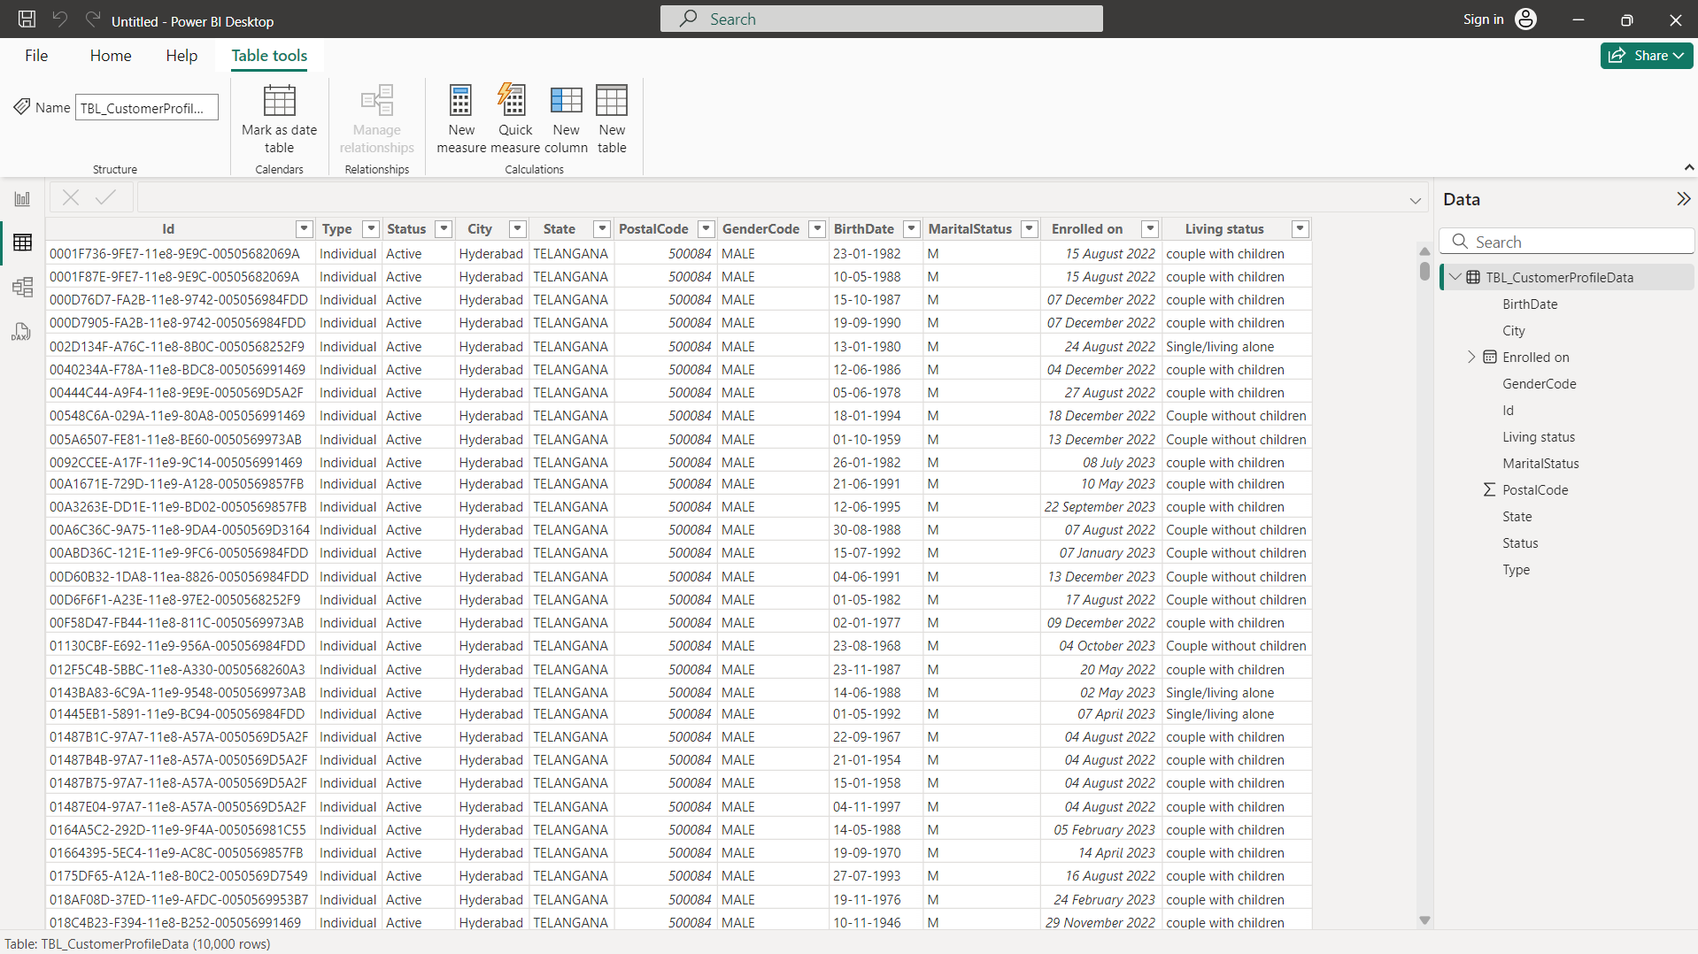

* **Conclusion :-**

The dataset analysis will provide actionable insights into customer demographics and engagement patterns with email marketing campaigns. These insights can guide businesses in designing more targeted and effective email marketing strategies, ultimately leading to improved customer retention and conversion rates. Further exploration can uncover region-specific trends and preferences, enabling a more localized approach to marketing.

By utilizing tools such as Power BI, Python, and Excel, this project demonstrates the power of data-driven decision-making in enhancing email marketing outcomes in the Indian market.

*Work 1 Submit By :- Pratap Mahata , AICTE ( Internship Student Registration ID) : STU63e97a4db9f371676245581*